Akira Govender

University of the Western Cape

Robert Sobukwe Road

Bellville 7530, Western Cape, South Africa

021 959 3426

3540386@myuwc.ac.za

Professor Mark J. Gibbons

Editor

*South African Journal of Marine Science*

11 June 2018

Dear Professor Gibbons

I am submitting a manuscript for consideration of publication in the *African Journal of Marine Science*. The manuscript is entitled “The effect of diverse temperature regimes on asexual polyp growth of two scyphozoan species: *Chrysaora fulgida* and *Chrysaora agulhensis,* found along the west coast of southern Africa”. This manuscript has not been published and is not under consideration for publication elsewhere. All contributors including myself, confirm that we have conformed to the principles outlined in the *Ethical considerations in research publication* guideline.

In this manuscript, we show that different temperature regimes have significantly different effects on both reproductive as well as growth rates of *Chrysaora fulgida* and *Chrysaora agulhensis.* We further discussed possible factors that may have influenced the results and the implications of such factors. We believe that this manuscript is appropriate for publication by the *African Journal of Marine Science* as it highlights pertinent biological processes regarding complex marine scyphozoan species, which falls in line with the marine based subject matter of this esteemed journal.

All contributing authors have read the final manuscript and have approved it for submission.

Their contact details have been included below. As corresponding author, I request that any queries or correspondence be forwarded to me.

Thank you for your time and consideration.

Sincerely,

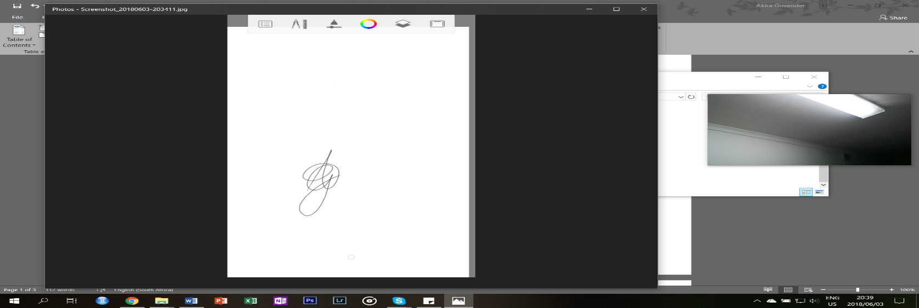

Akira Govender, BSc

Student, Department of Biodiversity and Conservation Biology

University of the Western Cape

Contact Details of Authors:

Akira Govender (corresponding author) – [3540386@myuwc.ac.za](mailto:3540386@myuwc.ac.za)

Amieroh Abrahams – [3559244@myuwc.ac.za](mailto:3559244@myuwc.ac.za)

Joshua Adrian – [3540394@myuwc.ac.za](mailto:3540394@myuwc.ac.za)

Kylen L. Brown – [3540337@myuwc.ac.za](mailto:3540337@myuwc.ac.za)

Carlin V. Landsberg – [3877568@myuwc.ac.za](mailto:3877568@myuwc.ac.za)

Jesse L. Smith – [3868892@myuwc.ac.za](mailto:3868892@myuwc.ac.za)

Kholofelo Sethebe – [3137355@myuwc.ac.za](mailto:3137355@myuwc.ac.za)

Luanne Thomas – [3437088@myuwc.ac.za](mailto:3437088@myuwc.ac.za)

Dhiren Vanmari – [3308987@myuwc.ac.za](mailto:3308987@myuwc.ac.za)

1. Title page

“The effect of diverse temperature regimes on asexual polyp growth of two scyphozoan species: *Chrysaora fulgida* and *Chrysaora agulhensis,* found along the west coast of southern Africa”

Amieroh Abrahamsa, Joshua Adriana, Kylen L. Browna, Akira Govendera,*, Carlin V. Landsberga, Jesse L. Smitha, Kholofelo Sethebea, Luanne Thomasa and Dhiren Vanmaria

a Department of Biodiversity and Conservation Biology, University of the Western Cape, Robert Sobukwe Road, Bellville 7530, South Africa

Corresponding author:

Corresponding author: Akira Govender*

Mailing address: University of the Western Cape, Robert Sobukwe Road, Bellville 7530, South Africa

Tel.: 021 959-3426

Mobile phone: 082 322 5472

E-mail: 3540386@myuwc.ac.za

2. Abstract

Scyphozoan*Chrysaora fulgida* and *Chrysaora agulhensis* are abundantlyfound along the west coast of southern Africa*.* Studies have shown that many factors may influence the proliferation of species such as these, however, changes in temperature is of the most apparent, with temperature cues controlling energy allocation during reproduction, which favour polyp budding at warmer temperatures or initiate strobilation when cold temperature thresholds are reached. Planulae morphing into viable polys with four tentacles, obtained from mature medusa of *Chrysaora fulgida* and *Chrysaora agulhensis,* collected from Walvis Bay and Whale Rock respectively, were incubated at 12, 14, 16, 18, 20, 22 and 24°C in order to decipher the effect that these different temperatures had on reproductive and growth rates. Fluctuations in growth rate pf polyps were observed, with an optimal growth rate occurring at 16-18°C. There was a directly proportional relationship between temperature and number of polyp’s present, as the temperature increased, the number of polyps increased. Factors such as light, salinity and nutrient availability may alter these results, however, should laboratory conditions be applicable to real-world functioning, faster strobilation and higher ephyra production may occur, resulting in intense blooms of these species.

Keywords: Asexual reproduction, Budding, Ephyrae, Polymorphic lifecycles, Temperature regimes, Temporal distribution

3. Introduction

The proliferation of jellyfish in marine ecosystems can often be attributed to factors that are the result of anthropogenic events. Amongst these factors, the most common are: (i) overfishing, which may indirectly decrease the abundance of natural predators and competitors of jellyfish, promoting unrestricted growth; (ii) the translocation of jellyfish species into novel habitats, resulting in harmful blooms; (iii) eutrophication, causing hypoxic conditions that are damaging to fish but not to jellyfish; and (iv) the propagation of artificial assemblies acting as possible substrates for scyphistomae (Pascual et al. 2014). One of the most prominent causes of a rapid increase in jellyfish populations is however, temperature (Purcell et al. 2009).

As temperature increases’ can affect the expansion rate of jellyfish populations, climate change plays an important role in this phenomenon. Studies conducted by Purcell et al. (2009) and Holst (2012), showed that an increase in temperature, resulted in an increase in asexual budding and ephyrae from scyphistomae. Temperature has also been shown to be positively correlated to jellyfish abundance at both a temporal and spatial scale in respect to their distributions (Purcell 2005; Purcell et al. 2007, 2012).

Abundant occurrences of jellyfish along coastal regions may impact a countries socio- economic status. In terms of tourism, an increase in medical emergencies regarding tourists whom are victims to the toxins, some of which are fatal, released by some species of jellyfish, may affect the number of tourists willing to come back to the region or may deter new ones from visiting (Mariottini & Pane 2010). With regards to the fisheries sector, large populations of jellyfish may reduce catch quality, resulting in a loss of income to this sector (Purcell et al. 2007). Whilst these organisms may have negative influences on the economy, they are also of interest to commercial fisheries worldwide as they influence trophic links between fish species (Purcell & Arai 2001).

The polymorphic lifecycle of scyphozoans, involve a short lived larval stage (planula), a benthic post-larval stage (polyp) and a pelagic sexual stage (medusa). Studies conducted by Lucas (2001) observed that *Aurelia* polyps asexually multiplied through polyp budding, underwent resting stages through podocyst formation or advanced their life cycle by the production of juvenile medusa via strobilation. Previous studies have illustrated that these ontogenetic processes are influenced by key environmental factors such as temperature, food, salinity and light. Temperature cues control energy allocation during reproduction, favouring polyp budding at warmer temperatures or initiating strobilation when cold temperature thresholds are reached (Lucas 2001).

The benthic post-larval stage is essential in the lifecycle of cnidarian jellyfish as it increases the abundance of clonal polyps through asexual reproduction (Han & Uye 2010). Examining the forces that stimulate growth during the polyp stage is, therefore, important in understanding the causes of medusa outbreaks. Most studies have examined responses in relation to environmental variables at the colony level (Han & Uye 2010), however, additional research is required in order to fully understand the current proliferation of jellyfish at the individual polyp level.

The effect of temperature on polyp growth and reproduction differs between species depending on where they are found in addition to their tolerance to different temperature ranges (Hubot et al. 2017; Pascual et al. 2014). In a study conducted by Pascual et al. (2014) on the response of different *Aurelia aurita s.l* populations to different temperatures, all populations showed an increase in budding in water of warmer temperatures, with strobilation occurring at a lower water temperature of 14° C for all populations. This study aims to examine the effects of different temperature regimes (12, 14, 16, 18, 22 and 24°C) on asexual polyp growth and the reproduction of two jellyfish species; *Chrysaora fulgida* and *Chrysaora agulhensis,* found along the west coast of southern Africa*.*

4. Methods and Materials

4.1 Sampling

For the purpose of this investigation, series A, B, C were all conducted with the same protocol despite being independent experiments. Mature medusa of *Chrysaora fulgida* were collected from Walvis Bay, placed in buckets and transported to the Two Oceans Aquarium located in Cape Town. Planulae were collected from the corners of the buckets and moved to 1 l Pyrex bowls containing filtered sea water (35 ppt at 15°C). Disposable petri dishes were placed at the bottom of the bowls, upon which planulae started to develop into polyps, 15 days later.

Mature medusa of *Chrysaora agulhensis* were collected from Whale Rock, off Robben Island, and transported to the Two Oceans Aquarium using the same bucket system. The protocol for this species was the same as for *Chrysaora fulgida*, except, the filtered sea water in the Pyrex bowls was altered to 18°C. In this case, polyp development occurred 10-15 days post planulae being added to the Pyrex bowls.

4.2 Laboratory analyses

The study was conducted at the University of the Western Cape, in the Marine Lab, with an ambient temperature of 14°C. The experiment, conducted over a three-month period, observed a number of daughter polyps produced by a mother polyp under seven different temperatures. Seven tanks in the lab acted as temperature baths for the experiment, with temperatures set to: 12, 14, 16, 18, 20, 22 and 24°C respectively. Temperatures ranging from 12-18°C were achieved using chillers whilst temperatures that ranged from 20-24°C were achieved using heaters, monitored with iButtons. Each tank was equipped with a 6.1 l glass beaker, one petri dish and filled with 300 ml of filtered and sterilized sea water.

Viable polyps with 4 tentacles were isolated in each plate and marked A, B, C, D, with unwanted polyps being removed using a paint brush. There were 48 petri dishes containing polyps that were prepped, with on 42 being used. The petri dishes were then randomly distributed among the seven temperature baths. Polyps were given five days to acclimatise to their respective temperatures before the commencement of any experiments. The sea water in each of the temperature baths was replaced every three days with water same as that of the original temperature.

One day (24 hours) before the water change, polyps were able to feed on 200 ml of *Artemia nauplii* placed in each of the beakers. Each polyp was examined on every third day before the water change. Many aspects were observed and recorded including: number and size of all polyps, polyp health, asexual reproduction, mode of asexual reproduction and the number of tentacles present on each individual. The reproductive rates were calculated over a period of a few days for each polyp. Series A was observed for a total of 87 days whilst series B and C were only observed for 36 days each.

4.3 Data Analysis

After collection, the experimental data was recorded onto a Microsoft© Excel spreadsheet. The spreadsheet was then converted into comma separated file (CSV) format. The statistical computing software, R Version 3.5.0, was then used to analyse the data and create graphic representations of the information that was collected. Two different ANOVA tests were used in order to determine if significant differences were present between the variables within the dataset. A two-way ANOVA test was used to determine whether there was a significant difference between the number of polyps present in each series for each age group. A one-way ANOVA test was used to determine if there was a significant difference present between the growth rate of each polyp in each series. In the statistical analyses, values less than that of 0.05, were considered statistically significant.

5. Results

The growth rate of each polyp in series A appeared to grow at a much slower rate than that of the polyps present in both series B and C (Figure 1). The polyps present in series A experienced an optimal growth rate at a temperature of 16°C. The growth rate of these polyps then slowly decreased as temperatures increased from 16°C to 22°C and finally began to slowly increase thereafter (Figure 1a). Series B showed a constant increase in the growth rate of each polyp, however, at a temperature of 18°C, there was a decrease in polyp growth followed by a rapid increase occurring from 20°C to 24°C (Figure 1b). Series C expressed the highest growth rate when compared to both series A and B. Here, polyp growth rate constantly increased until a temperature of 18°C. Growth rate decreased up until 22°C and thereafter increased again from 22-24°C (Figure 1c).

The highest number of polyps were present in series A, throughout the experiment (Figure 2a). The number of polyps present in series A, B and C all decreased at a temperature of 20°C (Figure 2). In series A, the cumulative number of polyps rapidly decreased between 16-22°C, which was then followed by a rapid increase after 22°C. Series A expressed a much higher cumulative number of polyps when compared to that of the other two series (Figure 2a).

Polyps need optimal conditions to grow and reproduce as seen in Figure 3. Warmer temperatures can be seen to promote an optimal growth rate for polyps (Figure 1 & 2). Results showed that polyps exposed to colder temperatures, take much longer to bud when in comparison to polyps growing in warmer temperatures (Figure 3).

The number of polyps present at low temperatures were relatively low (Figure 4). There was a directly proportional relationship between temperature and number of polyp’s present, as the temperature increased, the number of polyps increased. There were however, some outliers present which showed a constant increase in the cumulative number of polyp’s present. The cumulative number of polyps increased at a much greater rate in series A (Figure 4a), when compared series B (Figure 4b) and C (Figure 4c). Over a period of 36 days, the number of polyps were seen to increase slightly. Series A showed a steeper increase in the number of polyps present as this experiment took place over a period of 87 days whereas series B and C occurred over a period of 36 days (Figure 4).

The two-way ANOVA test concluded that there was a significant difference between the number of polyps present in each of the three series, at each of the age and temperature groups within the experiment with p < 0.05 (Table 1). The one-way ANOVA test concluded that a significant difference existed between the growth rate of polyps in each of the three series with p < 0.05 (Table 2).

6.Discussion

Temperature is a key factor in determining scyphozoan polyp strobilation and ephyrae release (Wang et al. 2015). The polyps of *Chrysaora fulgida* and *Chrysaora agulhensis* can be found along the west coast of southern Africa, where they are affected by the cool Benguela current. The Benguela current along the west coast of southern African experiences temperatures between 12-21ºC throughout the year (World Sea Temperatures 2018). As a result of this, the polyps were tested over a range of temperatures that exceeded but also included their natural environment. It can be said that the asexual growth of *Chrysaora fulgida* and *Chrysaora agulhensis* is influenced differently by changes in temperature. Studies show that scyphozoan species are able to thrive over a wide range of temperature conditions (Licandro et al. 2010; Purcell et al. 2012). An increase in strobilation of polyps is however, often triggered after exposure to a prolonged reduction in sea water temperature (Hubolt et al. 2017).

The results obtained in this investigation coincide with that of Chomsky et al. (2004), where the growth rate of *Actinia equina* polyps were not variable between 15-20ºC (the two lowest temperatures) or between 25-30ºC (two of the highest temperatures), indicating that temperature impacts are marginal over these ranges. The decrease in growth rates between 16-22°C in series A and C and between 18-21°C in series C could be attributed to the polyps adjusting to the elevated temperatures. This may represent thermal acclimation, where the suitable respiratory isozymes are activated, and the inappropriate isozymes denatured (Chomsky et al. 2004).

The decrease in the cumulative number of polyps could be explained by the slowing of the rate of budding as demonstrated by Liu et al. (2009), which could also explain the sudden increase where, after the budding rate of *A.aurita* decreased, a warmer temperature increased strobilation. This, may in turn, lead to an increase in production of ephyrae and subsequently, jellyfish. Warmer temperatures exponentially increase strobilation rate (Liu et al. 2009). Since the longer period of study in series A yielded more cumulative numbers, it can be concluded that the limit in temperature for survival is beyond 24ºC. Widmer (2005), conducted an experiment in which it was seen that heat stress at very high, prolonged temperatures have been observed in scyphomedusae such as *A. labiate,* which perished after prolonged exposure to this heat stress. The decrease in the cumulative number of polyps may be owed to the lower number of individuals of *Chrysaora agulhensis* species, which could have reacted differently to the experimental conditions in comparison to *Chrysaora fulgida*.

Although warmer temperatures increase the rate of reproduction, there are costs to the growth and size of polyps that need to be taken into consideration (Valenzuela and Lance 2004). Changes in several factors such as temperature, salinity, light and food have an effect on the rate of reproduction and cannot be investigated independently (Purcell 2007). Another factor to consider, is that each population is adapted to the local condition it is found in and therefore will respond differently to a change in temperature (Purcell 2007).

It can be concluded that polyps bud in cool temperatures and strobilate in warmer temperatures as proved in this investigation. Polyps habitually rest or bud prior to the reception of cues for strobilation (Liu et al. 2009). Constant warming may result in the improper timing of strobilation, giving polyps not enough time to acquire sufficient energy for revival, therefore causing populations to diminish (Liu et al. 2009). Although many jellyfish have been observed strobilating after in situ temperature decreases (Lucas 2001), it can be concluded that, should laboratory conditions be applicable to real-world functioning, faster strobilation and higher ephyra production is possible, resulting in intense blooms, with decreased budding and higher mortalities subsequently decreasing these populations (Liu et al. 2009).

7. Acknowledgments

We would like to extend our appreciation towards Krish Lewis from the Department of Biodiversity and Conservation Biology at the University of the Western Cape for the collection of the data. We would also like to thank the Department of Natural Science at University of the Western Cape for the use of their well-equipped laboratories, in which the experiment was conducted.

8. References

Chomskya O, Kamenira Y, Hyamsa M, Dubinskya Z, Chadwick-Furman NE. 2004. Effects of temperature on growth rate and body size in the Mediterranean Sea anemone *Actinia equina*. *Journal of Experimental Marine Biology and Ecology* 313: 63‒73.

Han C, Uye S. 2007. Combined effects of food supply and temperature on asexual reproduction and somatic growth of polyps of the common jellyfish *Aurelia aurita* *s.l.* *Plankton Benthos Research* 5: 98–105.

Holst S. 2012. Effects of climate warming on strobilation and ephyra production of North Sea scyphozoan jellyfish. *Hydrobiologia* 690: 127–140.

Hubolt N, Lucas CH, Piraino S. 2017. Environmental control of asexual reproduction and somatic growth of *Aurelia spp.* (Cnidaria, Scyphozoa) polyps from the Adriatic Sea. *PLoS ONE* 12: e0178482.

Licandro P, Conway DVP, Daly Yahia MN, Fernandez de Puelles ML, Gasparini S, Hecq JH, Tranter P. 2010. A blooming jellyfish in the northeast Atlantic and Mediterranean. *Biology Letters* 6: 688‒691.

Liu W, Lo W, Purcell JE, Chang H. 2009. Effects of temperature and light intensity on asexual reproduction of the scyphozoan, *Aurelia aurita* (L.) in Taiwan. *Hydrobiologia* 616: 247–258.

Lucas CH. 2001. Reproduction and life history strategies of the common jellyfish, *Aurelia aurita*, in relation to its ambient environment. *Hydrobiologia* 451: 229‒246.

Pascual M, Fuentes V, Canepa A, Atienza D, Gill J, Purcell JE. 2014. Temperature effects on asexual reproduction of the scyphozoan *Aurelia aurita* *s.l*.: differences between exotic (Baltic and Red seas) and native (Mediterranean Sea) populations. *Marine ecology* 36: 994‒1002.

Purcell JE. 2005. Climate effects on formation of jellyfish and ctenophore blooms: a review. *Journal of the Marine Biological Association of the United Kingdom* 85: 461–476.

Purcell JE. 2007. Environmental effects on asexual reproduction rates of the scyphozoan *Aurelia labiata*. *Marine Ecology Progress Series* 348: 183‒196.

Purcell JE. 2012. Jellyfish and ctenophore blooms coincide with human proliferations and environmental perturbations. *Annual Review of Marine Science* 4: 209–235.

Purcell JE, Uye S, Lo W. 2007. Anthropogenic causes of jellyfish blooms and their direct consequences for humans: a review. *Marine Ecology Progress Series* 350: 153–174.

Purcell JE, Hoover RA, Schwarck NT. 2009. Interannual variation of strobilation by the scyphozoan *Aurelia labiate* in relation to polyp density, temperature, salinity, and light conditions in situ. *Marine Ecology Progress Series* 375: 139–149.

Purcell JE, Atienza D, Fuentes V, Olariaga A, Tilves U, Colahan C, Gili J. 2012. Temperature effects on asexual reproduction rates of scyphozoan species from the northwest Mediterranean Sea. *Hydrobiologia* 690: 169‒180.

Valenzuela N, Lance V. 2004. General effects of temperature on animal biology. In: McCue MD, *Temperature-dependent sex determination in vertebrates*. Washington DC: Smithsonian Books. pp 71‒78

Wang Y, Zheng S, Sun S, Zhang F. 2014. Effect of temperature and food type on asexual reproduction in *Aurelia* sp.1 polyps. *Hydrobiologia* 754: 169‒178.

Widmer CL. 2005. Effects of temperature on growth of north-east Pacific moon jellyfish ephyrae, *Aurelia labiata* (Cnidaria: Scyphozoa). *Journal of the Marine Biological Association of the United Kingdom* 85: 569–573.

World Sea Temperatures. 2018. *2018 Africa Sea Temperature*. Available at https://www.seatemperature.org/africa/south-africa/cape-town.htm [accessed 9 June 2018].

9. Figure Titles

Figure 1. Line graphs portraying the relationship between the growth rate of each polyp at various temperatures ranging from 12°C till 24°C for each of the series: (a) Series A, (b) Series B and (c) Series C.

Figure 2. Line graphs portraying the relationship between the number of polyps present at various temperatures ranging from 12°C till 24°C for each of the series: (a) Series A, (b) Series B and (c) Series C.

Figure 3. Line graphs representing the growth rate of polyps on various days with each line colour representing a different temperature for each of the series: (a) Series A, (b) Series B and (c) Series C.

Figure 4. Line graphs representing the relationship between the number of polyps present on the various days with each line colour representing a different temperature for each of the series: (a) Series A, (b) Series B and (c) Series C.

10. Table Titles

Table 1: A two-way ANOVA test comparing the number of polyps present in each series: Series A, B and C, for each of the age groups.

Table 2: A one-way ANOVA test comparing the growth rate of each polyp present in each series: Series A, B and C.

11. Figures

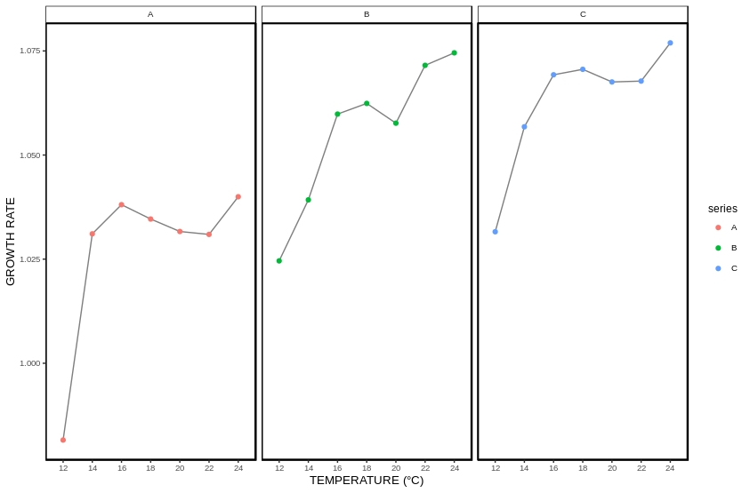

(c)

(b)

(a)



Figure 1. Line graphs portraying the relationship between the growth rate of each polyp at various temperatures ranging from 12°C till 24°C for each of the series: (a) Series A, (b) Series B and (c) Series C.

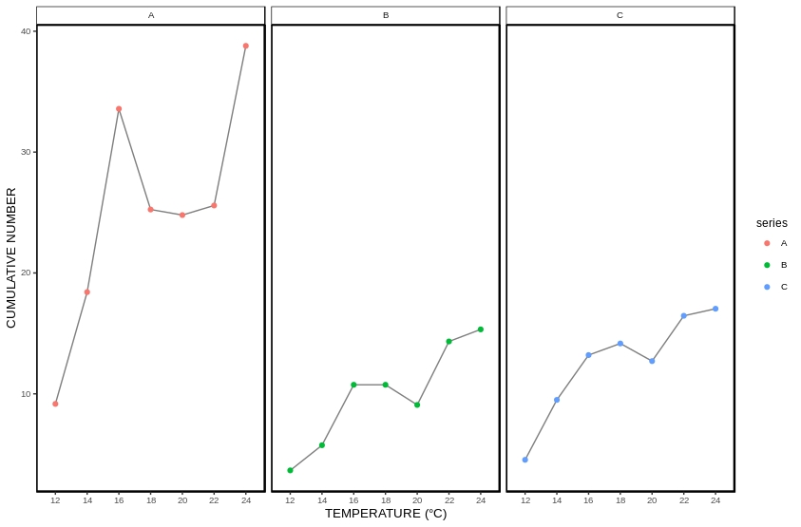

(b)

(c)

(a)



Figure 2. Line graphs portraying the relationship between the number of polyps present at various temperatures ranging from 12°C till 24°C for each of the series: (a) Series A, (b) Series B and (c) Series C.

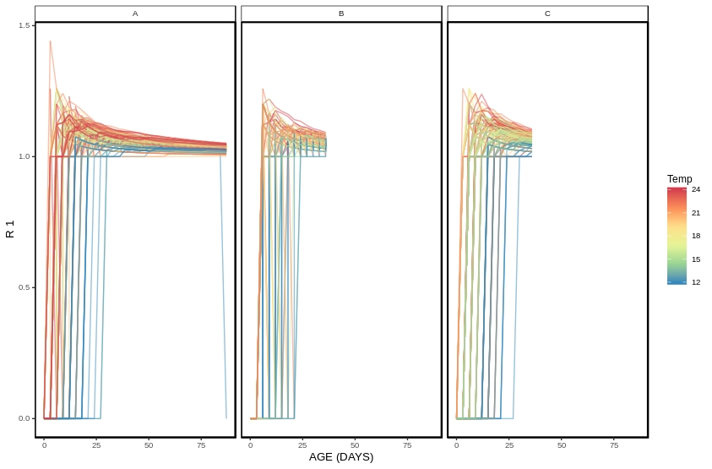

(c)

(b)

(a)



Figure 3. Line graphs representing the growth rate of polyps on various days with each line colour representing a different temperature for each of the series: (a) Series A, (b) Series B and (c) Series C.

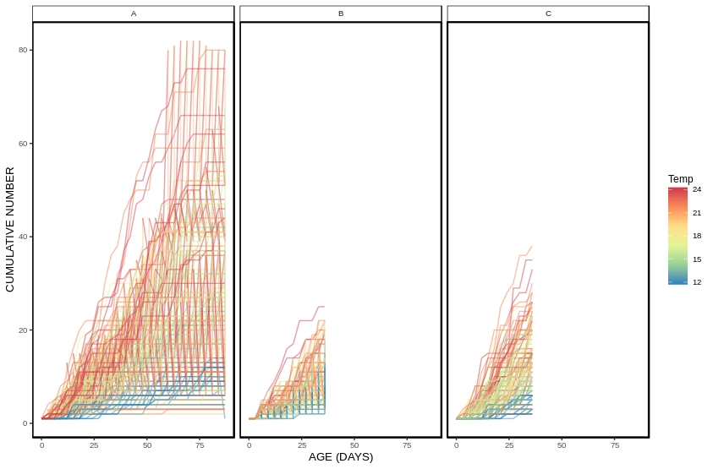

(c)

(a)

(b)



Figure 4. Line graphs representing the relationship between the number of polyps present on the various days with each line colour representing a different temperature for each of the series: (a) Series A, (b) Series B and (c) Series C.

12. Tables

Table 1: A two-way ANOVA test comparing the number of polyps present in each series: Series A, B and C, for each of the age groups.

|  |  |  |  |  |  |
| --- | --- | --- | --- | --- | --- |
|  | Df | Sum Sq | Mean Sq | F value | Pr(>F) |
| Temperature | 6 | 615,5 | 102,6 | 27,037 | 0,000167 |
| Age | 1 | 894,9 | 894,9 | 235,866 | 1,20E-06 |
| Temperature as a factor of age | 6 | 158,6 | 26,4 | 6,966 | 0,010931 |
| Residuals | 7 | 26 | 3,8 | - | - |

Table 2: A one-way ANOVA test comparing the growth rate of each polyp present in each series: Series A, B and C.

|  |  |  |  |  |  |
| --- | --- | --- | --- | --- | --- |
|  | Df | Sum Sq | Mean Sq | F value | Pr(>F) |
| Series | 2 | 918 | 495 | 10,62 | 0,000897 |
| Residuals | 18 | 777,6 | 43,2 | - | - |

